Entity Relationship Diagram
An Entity Relationship Diagram (ERD) was created for the beverages database to detail an appropriate schema based on the information provided. Due to inconsistencies within the input files, the ERD will detail a schema that will maintain entity and referential integrity. Entity integrity will allow for each entry in each table to be distinguished from other rows and referential integrity will allow for changes in one table to be reflected in another (Curry, 2016). The integrity of the beverages database defined in the ERD will ensure data is accurate and usable for end users and ultimately benefit the data governance of the organization.
The figure below displays the Entity Relationship Diagram (ERD) for the beverages database:
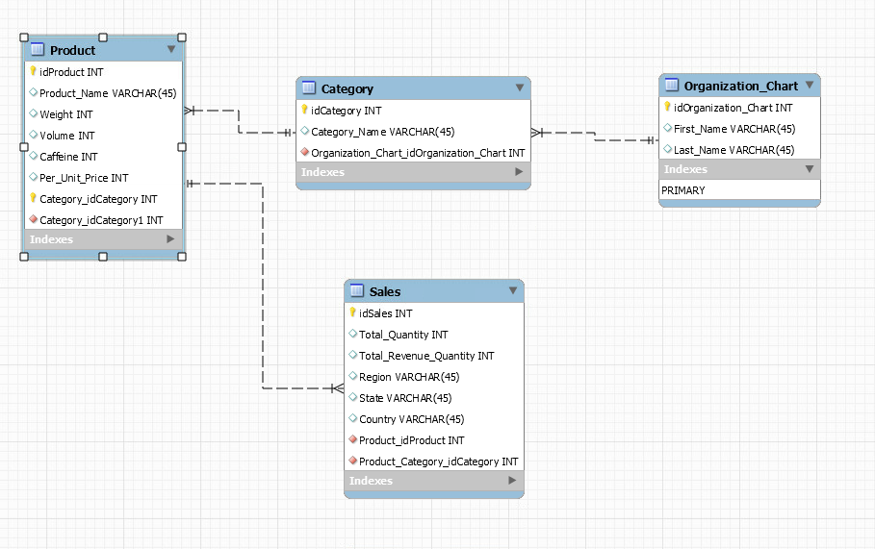
Fig.1 Entity Relationship Diagram for Beverages Database

Entity Relationships
The relationships between entities describe how entities relate to each other. The type of relationship defines how to classify the data and how an action to one entity affects the other. The current structure of the beverages database along with the provided input data, the relationships between entities can be inferred. Entities contain primary keys to maintain integrity as well as foreign keys to maintain referential integrity. Together, the entities form a relationship to benefit overall domain integrity and support data governance.

The relationships defined in the ERD are as follows:
One-to-Many:
- Product-Category: Multiple products can belong to a single category
- Sales-Product: Multiple sales can involve each product
- Category-Organization Chart: Multiple categories can be controlled by a vice president
Product Table
The product table defines each product and its corresponding details. The table contains a primary key labeled idProduct followed by the product name, category, weight, volume, and caffeine. It shares a one-to-many relationship with the Category table as multiple products can correspond to a category and a one-to-many relationship with the sales table as each product can correspond to multiple sales.
The fields are defined as follows:
- idProduct/Category_idCategory: primary key
- Product_Name: name of product
- Weight: weight of a single serving of the product
- Volume: volume of a single serving of the product
- Caffeine: amount of caffeine in a single serving of the product
- Per_Unit_Price: cost for a single serving of the product
- Category_idCategory1: foreign key relates to the Category table
Category Table
The category table defines each category that the individual product belongs to. The table contains a primary key labeled idCategory followed by the category name. The table has a one-to-many relationship with the product table and a one-to-many relationship with the Organization_Chart table as multiple categories can relate to a single vice president.
The fields are defined as follows:
- idCategory: primary key
- Category_Name: name of category
- Organization_Chart_idOrganization_Chart: foreign key relates to the Organization Chart table
Organization Chart Table
The organization chart table defines the first and last names of the vice presidents within the organization. The table contains a primary key labeled idOrganization_Chart followed by the first and last names. The table has a one-to-many relationship with the Category table as each vice president can represent multiple categories.

The fields are defined as follows:
- idOrganization_Chart: primary key
- First_Name: first name of vice president
- Last_Name: last name of vice president
Sales Table
The sales table defines the sales data of beverage products. The primary key within the table is labeled idSales followed by total quantity, total revenue quantity, region, state, and country. The table has a one-to-many relationship with the Product table as one product can correspond to multiple sales.
The fields are defined as follows:
- idSales: primary key
- Total_Quantity: sum of all quantities sold
- Total_Revenue_Quantity: sum of all revenue quantity sold
- Region: region where product was sold
- State: state where product was sold
- Country: country where product was sold
- Product_idProduct: foreign key relates to the Product table
- Product_Category_idCategory: foreign key relates to the Product table due to the one-to-one relationship between the Product table and Category table

ETL Process for Consolidation of Data
Overview: The ETL process is important in successfully meeting the business requirements in consolidating the beverage sale data for the years 2021, 2022, 2023. Beverage sale data were found to be in various formats in addition to having missing columns. The goal of the ETL process is important for analytical infrastructure to ensure accurate data for business intelligence and reports to stakeholders (Levins et.al, 2021). The process below details the extraction of data from the input files, transformation of the data to a consolidated table, and the loading of beverage sales data to a final table for use by end users.
The ETL Process involves:
- Extraction of the beverage sale data from 2021-2023 to the beverages database
- Transformation and consolidation of the data for structure and consistency
- Loading into a final table which can be used for analysis and reporting

- Extract Phase
  - The extraction phase involves utilizing the Table Import Wizard in MySQL. Each input file is imported with the tool and stored in the beverages database
  - Data to be extracted is in csv format
  - Extracted data includes:
    - Product Name
    - Caffeine
    - Quantity
    - Volume
    - Weight
    - Region
    - State
    - Country

- Transform Phase
  - The transform phase involves formatting and standardizing the data and consolidating the data with the category and organization chart tables
  - Data Formatting:
    - The input 2021 input file is missing the caffeine field and it will need to be added for the final output
    - All input files are missing a year field necessary for the final output table
      - A caffeine field with INT data type is created for the beverage2021 table
      - A year field with INT data type is created for the beverage2021, beverage2022, and beverage 2023 tables
    - The year field in each table will need to be populated with the corresponding year for the final output
      - Determine the unique products in each table and populate the appropriate year for each table for each unique product

  - Data Transformation:
    - The data from each table will need to be merged with the required data from the category and organization chart tables
      - Only vice presidents: Remi Olson, Bodhi Perry, Rowan Walsh, and Buford Jackson are to be retrieved. Include all data from the organization table
      - Retrieve the appropriate columns defined by the business requirements The view should display:
        - Product
        - Weight
        - Volume
        - Caffeine
        - Price Per Unit
        - Category
        - Region
        - State
        - Country
        - First Name
        - Last Name
        - Year
        - Calculated Fields:
          - Volume Quantity
          - Weight Quantity
            - Volume quantity and weight quantity are calculated through multiplying the quantity with the volume and weight respectively
          - Revenue Quantity.
            - Revenue quantity is calculated through multiplying the quantity by price per unit
      - Order the result by last name, category, and product
    - The result is exported through the Table Export Wizard as an appropriately labeled csv file (ensure the year is in the file name)
    - Each exported csv will need to be imported through the Table Import Wizard to the beverages database to merge all data into a consolidated table
    - Once imported, select the required columns in the correct order from the consolidated 2021 table and merge with the consolidated 2022 and 2023 tables to form one consolidated beverage table
    - The table is exported through the Table Export Wizard as a consolidated csv file with 2021-2023 beverage data
- Load Phase
  - The data loading phase will load data from the consolidated table into one final table to be delivered to stakeholders
  - The consolidated beverage table is imported through the Table Import Wizard
  - The final table will need to have the required fields in the correct order
  - Data Loading
    - Select the required fields to fulfill the business requirements and produce a final output table in the correct order:
      - Last Name
      - First Name
      - Year
      - Category
      - Product
      - Country
      - Region
      - State
      - Weight
      - Volume
      - Caffeine
      - Per Unit Price
      - Calculated fields:
          - Quantity Sum
          - Revenue Quantity Sum
            - A SUM function will be used on the Quantity and Revenue_Quantity fields to determine the Total Quantity and Total Revenue Quantity Fields
    - Order the results by last name, first name, year, category, product, country, region, and descending by revenue quantity sum
  - The table is exported through the Table Export Wizard as the final output

Metadata
Metadata is necessary for analytical infrastructure and provides context for end users to understand the data and supports data governance (Levins et.al, 2021). Documentation of metadata ensures data will remain organized, provides information pertaining to database schema, and will retain security by defining data relationships. Descriptive attributes will benefit users when performing analytical processes and effective metadata documentation ensures proper data storage and organization (Chia, 2023). The metadata for the final beverage data file details the information about the data and its structure.

- Data Description:
  - The data contains sales data of beverage products during the years 2021, 2022, and 2023. Each product is structured by year, geographic area of sale, and the vice president whom represents the product. Total amount sold and total revenue from each transaction is recorded.
- Data Source:
  - Organization: UMGC
  - Class: DATA 635
  - Semester: Fall 2024
  - Unit: 6
  - Documents:
    - G5_Output_Final.csv (22KB)
- Data Dictionary:
  - Last Name: last name of vice president
  - First Name: first name of vice president
  - Year: year corresponding to sales
  - Category: category of product
  - Product: name of product
  - Country: country of sale
  - Region: geographic region where sale occurred
  - State: name of state where sale occurred
  - Weight: weight of a single serving of the product (g)
  - Volume: volume of a single serving of the product (mL)
  - Caffeine: caffeine content of a single serving of the product (mg)
  - Per Unit Price: cost of a single serving of the product (pennies)
  - Total Quantity: total quantity sold of the product
  - Total Revenue Quantity: total revenue from the sale of the product

References
- Inmon, B., Levins, M., & Srivastava, R. (2021). Building the data lakehouse. Technics Publications.
- Curry, C. (2016, December 20). MySQL 11 - Entity integrity [Video]. YouTube. https://www.youtube.com/watch?v=wCOpSR-_VvA
- Curry, C. (2016, December 21). MySQL 12 - Referential integrity [Video]. YouTube. https://www.youtube.com/watch?v=Q2XnoPDWwmY
- Chia, A. (2023, May 11). Database management systems (DBMS): The beginner’s guide. Splunk-Blogs. https://www.splunk.com/en_us/blog/learn/dbms-database-management-systems.html

